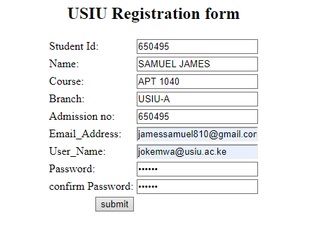

<html>

<head>

<title> USIU registration form</title>

</head>

<h2 ALIGN="CENTER"> USIU Registration form</h2>

<form action="Welcome.html" method="post">

<table border="0" align="center">

<tbody>

<tr>

<td><label for="id"> Student Id: </label></td>

<td><input id="id" maxlength="50" name="name" type="text" /></td>

</tr>

<tr>

<td><label for="name">Name: </label></td>

<td><input id="name" maxlength="50" name="name" type="text" /></td>

</tr>

<tr>

<td><label for="course">Course: </label></td>

<td><input id="course" maxlength="50" name="course" type="text" /></td>

</tr>

<tr>

<td><label for="branch">Branch: </label></td>

<td><input id="branch" maxlength="50" name="branch" type="text" /></td>

</tr>

<tr>

<td><label for="rolln0">Admission no: </label></td>

<td><input id="rollno" maxlength="50" name="rollno" type="text" /></td>

</tr>

<tr>

<td><label for="email">Email_Address:</label></td>

<td><input id="email" maxlength="50" name="email" type="text" /></td>

</tr>

<tr>

<td><label for="username">User_Name:</label></td>

<td><input id="username" maxlength="50" name="username" type="text" /></td>

</tr>

<tr>

<td><label for="password">Password:</label></td>

<td><input id="password" maxlength="50" name="password"

type="password" /></td>

</tr>

<td><label for="password">confirm Password:</label></td>

<td><input id="password" maxlength="50" name="password"

type="password" /></td>

</tr>

<tr>

<td align="right"><input name="Submit" type="Submit" value="submit" /></td>

</tr>

</tbody>

</table>

</form>

</html>